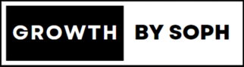
Walkthrough of the App
Overview of the 4 main screens
At the bottom of your app, you will find 4 tabs to access the main screens - Today, Coaching, Inbox, and You. These 4 screens will guide you through the training program which I have designed for you.
- Today: This screen shows all the workouts and tasks that you are assigned for today.
- Coaching: This screen allows you to view a broader schedule of your workouts and tasks.
- Inbox: This screen is where you can direct message me.
- You: This screen is where you can set your goal, view metrics, and track your progress.

Today
The Today screen is dedicated to summarising your activities of the day — and to make it easy for you, this is where you will start every time you launch the app.
On the Today screen, you can find up to 6 main sections - Training, Tasks, Steps Tracking, Food Journal and Notifications. The display of these will be adaptive based on what you have been assigned for the day. (Learn more)
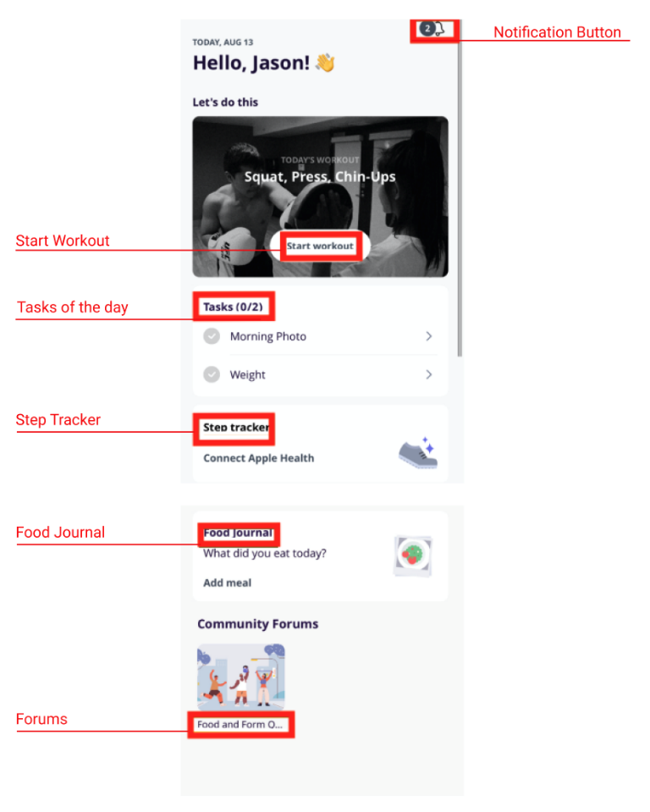
If you use a food tracker app such as MyFitnessPal (which I recommend), you can connect this to the app and your daily calorie consumption on the front page will update automatically. If you would prefer to journal your food, please use the food journal tab to do so including as much detail as possible (e.g. two tablespoons of peanut butter, one New York bagel, flora butter).

Coaching
The Coaching tab houses your weekly training and task schedules. You’ll be able to take a look at an overview of workouts and exercises that have been assigned to you here.
You can expand the Training overview and see more than one week by clicking on the training section.
If you need to reschedule your workouts, you can click the rectangular arrow shape in the right hand corner, and drag the workouts using the three lines on the right of the workout title.

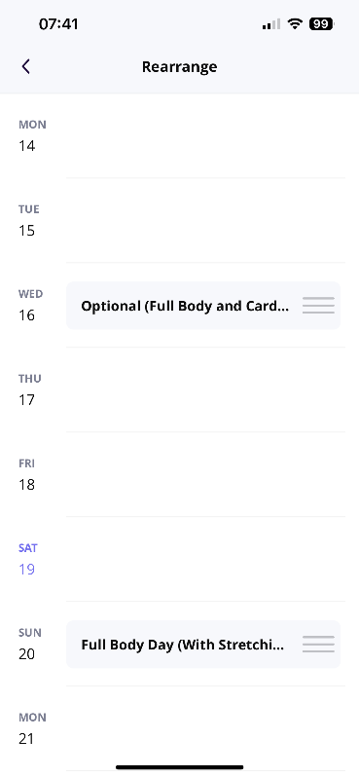
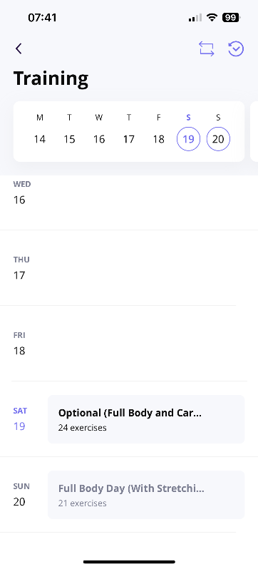
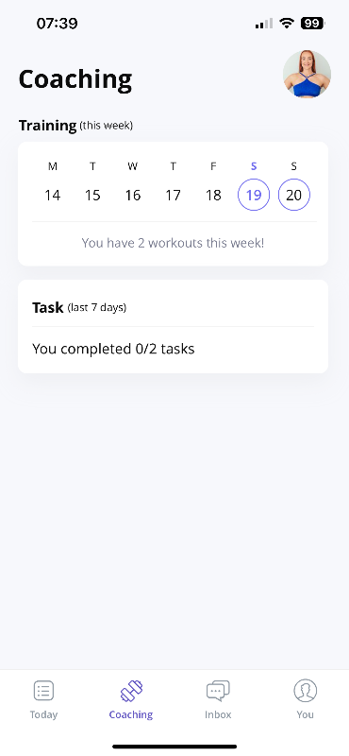

Inbox
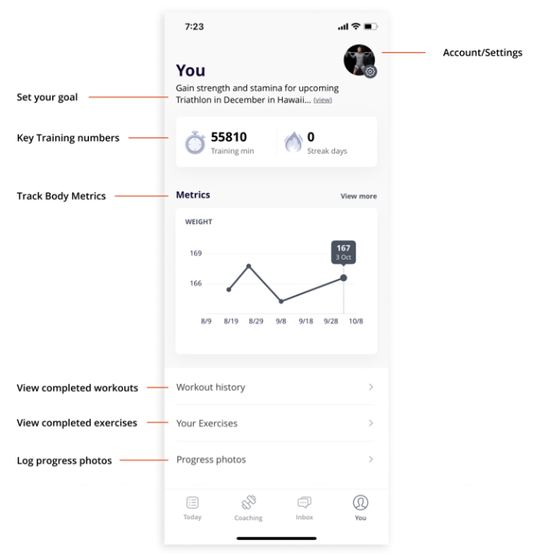
Just as any other messaging platform, here you can direct message me. Ask questions, send a video, you can do it all from the Inbox.
You
The You tab is all about ... YOU and your training results. We’ve made it easier for you to track your progress by including different sections that showcase what you have accomplished.

My goal is to keep you motivated and consistent with your training regime, so you can achieve your goals better.

